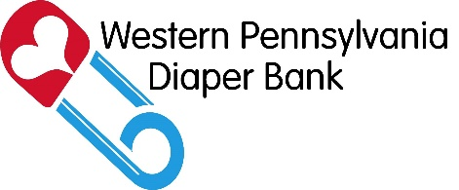...

**What**: Diaper Drive to collect diapers (or the funds to buy them!) for babies in need in Western Pennsylvania

**When**: [Time Frame for Diaper Drive]

**Who**: [Group Name] and Western Pennsylvania Diaper Bank

**Where**: [Drop-off location for diapers]

**Why**: One in three American moms struggles to provide clean diapers for her children. Food stamps and WIC don’t cover diapers and families often are forced to make tough decisions regarding day care and employment because they can’t afford diapers.

The Western Pennsylvania Diaper Bank partners with local social service organizations to distribute diapers free of charge to families in need. Diapers collected at our drive will go directly to families in our community.

**Get behind our diaper drive!**

Your Group Logo

[**www.wpadiaperbank.org**](http://www.wpadiaperbank.org)